Logging into the Neptun System
As an instructor, you can access the Neptun system through the Neptun Portal:
https://neptunweb.semmelweis.hu/oktato/login.aspx
Supported browsers: Internet Explorer 8+, Mozilla Firefox 3.6+
On the login page, enter:
- Login name: Neptun code
- Password: for first login, use your date of birth in the format YYYYMMDD, if you have not changed it previously.

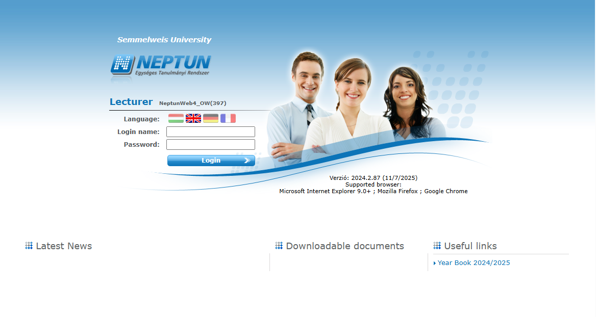

Main menu options after login:
- My Data
- Instruction
- Exams, grade submission
- Information
- Administration
- Degree thesis

Instuction Menu
Courses and grade entry are available under the Subjects section.

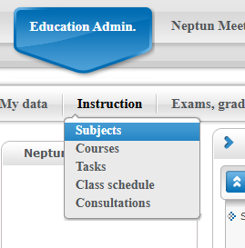
I. Subjects
- You can list your taught and own subjects, filtered by semester and subject type:
  - Own subject: where you are the responsible instructor
  - Taught subject: where you teach a course of the subject
- Doctoral School subjects start with the code DI.

Click the “+” icon at the end of the subject row for more options, then select Subject’s Courses.
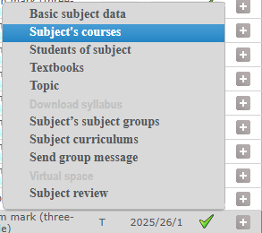

When you click on Subject’s Courses, on the new page select that Doctoral Division in which the student(s) studies, then click the “+” button at the end of the chosen row to access the Grade submission option.
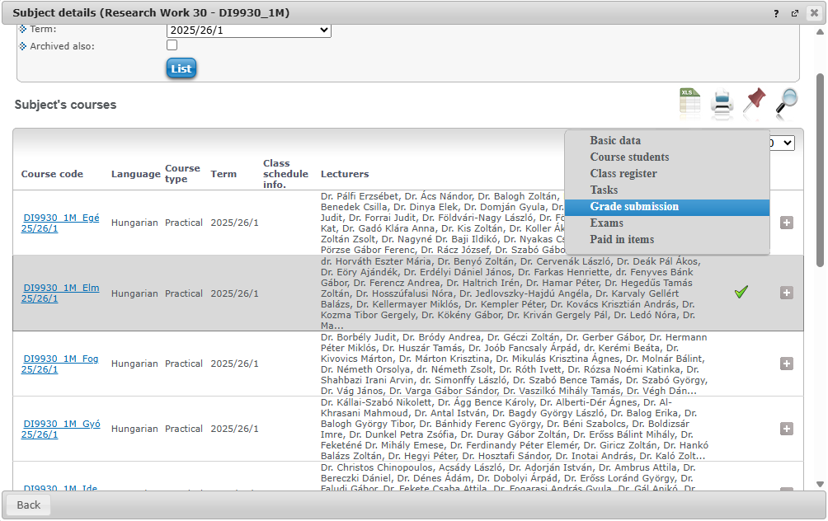

Grade submission
You need to record both the Lecturer’s signature and Term mark for the course students.

Entering Signature (per student):
- Method of remark: Register entry by user
- Entry type: Lecturer’s signature
- In the student list, select: Signed or Rejected
- Save

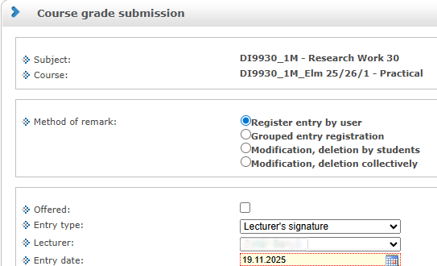
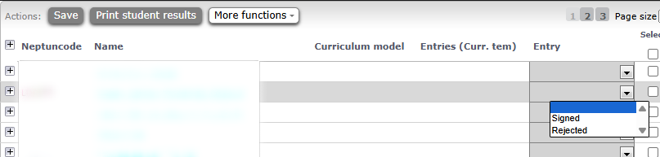

Entering Term mark (per student):
- Method of remark: Register entry by user
- Entry type: Term mark (three degree)
- Select the signing instructor
- In the student list, choose:
  - Unsatisfactory
  - Average
  - Excellent
- Save

