Semmelweis University Doctoral Council
and the Doctoral School of Pathological Sciences
invite you to the defense of doctoral dissertation of
Emese Irma Ágoston, MD.
entitled

The clinicopathological implication of biomarker expression diversity in specific regions of
colorectal tumours and their corresponding metastases

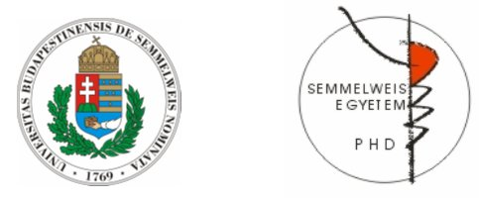

The date of defence:
6th May 2024 at 2PM
The place of defence:
Simonyi Room, Department of Internal Medicine and Oncology, Semmelweis University

Supervisor: Attila Marcell Szász MD, PhD.
Consultant: László Harsányi MD, PhD.
Head of the Program: András Kiss, MD, PhD.
Head of the Doctoral School: András Matolcsy, MD, DSc.

President of the evaluation committee: Pál Ondrejka, MD, PhD.

Committee members: Opponents:
Kristóf Dede, MD, PhD. Zoltán Kukor, MD, PhD.
Ákos Szűcs, MD, PhD. László Landherr, MD, PhD.

Budapest, 2024

