PROINFLAMMATORY ACTIVATION OF
ENDOTHELIAL CELLS

PhD thesis

Veronika Makó

Semmelweis University Doctoral School
… Division

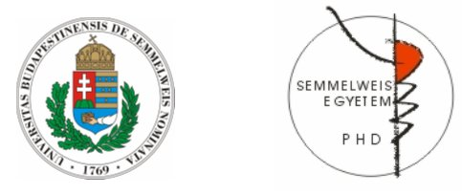

Supervisor: Zoltán Prohászka, MD, D.Sc
Official reviewers: Péter Hamar, MD, Ph.D
István Krizbai, MD, Ph.D

Head of the Complex Examination Committee: Imre Oláh, MD, D.Sc

Members of the Complex Examination Committee: Éva Pállinger, Ph.D
Gábor Réz, Ph.D

Budapest
2019

