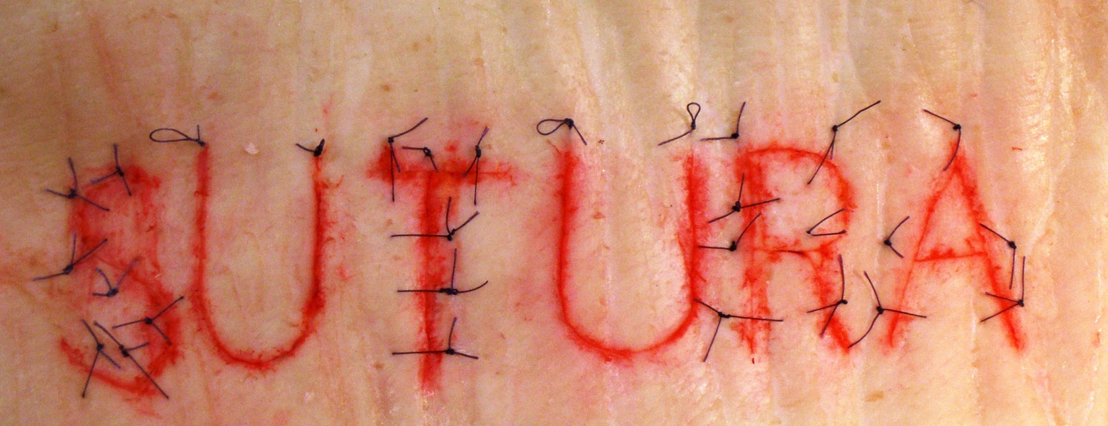
„Sutura” competition
2nd Semester of 2021/2022 Academic Year

In the 2nd Semester of the 2021/2022 Academic Year „Sutura” competition for the fifth time was held in the Operating Lab of the Department of Surgical Research and Techniques on 29th March 2022 by the English program students. One person was selected from each group of 3rd-year medical students, who presented the best skill during the wound closure practices.
There were two rounds in total. In round one at the beginning, the participants performed the Running-lock suture with 8 stitches that had 16 points and each knot 2 points. They have learned this suture line earlier in the practices. Teachers evaluated each student’s suture line according to the quality of stitches (20 points) and timing (10 points) factors such as:
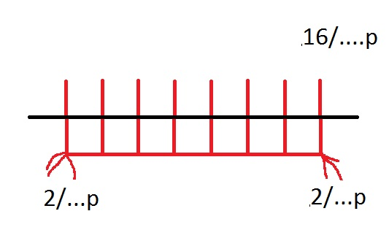
- Symmetry
- Tightening of the knot
- Distances from wound edges
- Knot location
- Time

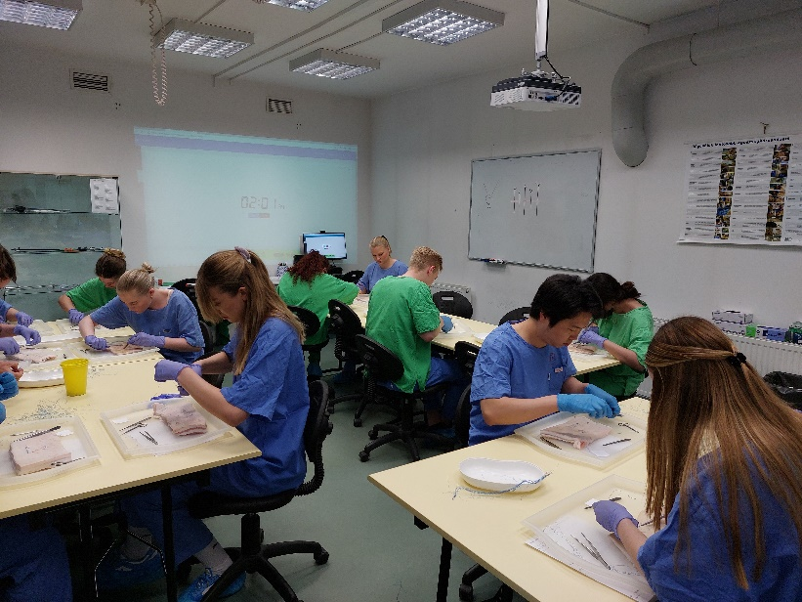

17 students took part in the first round, the first 13 students could win this round and be allowed to participate in the second part of the competition. All other participants are exempt from the sutura exam station.

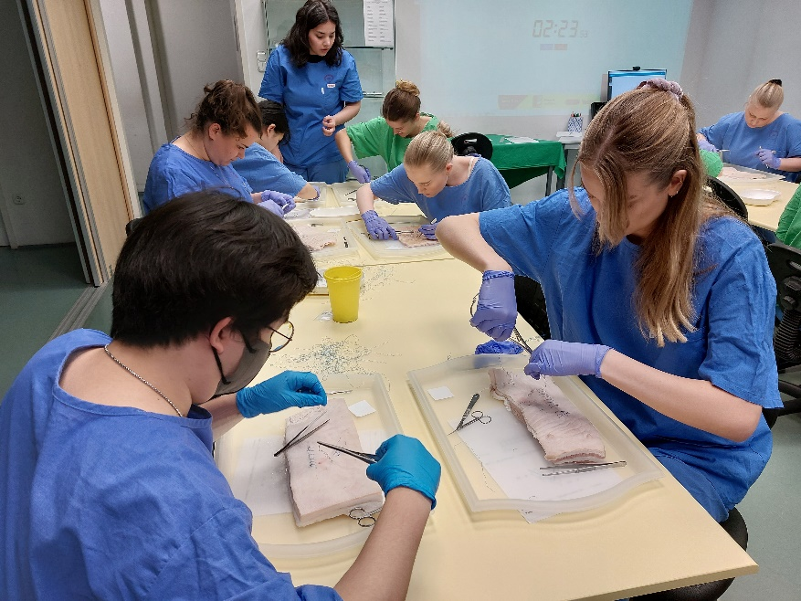
On the second part, thee student made a V-shape incision on the skin, than they performed 2 Horizontal mattress suture lines each for 4 points and one horizontal Allgöwer stitching for a maximum of 12 points. The second suture line, the Horizontal mattress suture was the real challenge because it was a new type of suture for the students. Speed was also an important factor, the fastest student received 10 points, while the slowest got 0 point. Thus, a total of 30 points could be achieved. If a student handled the instrument incorrectly Points were reduced.
V
4/..….p
4/…...p
12/…...p

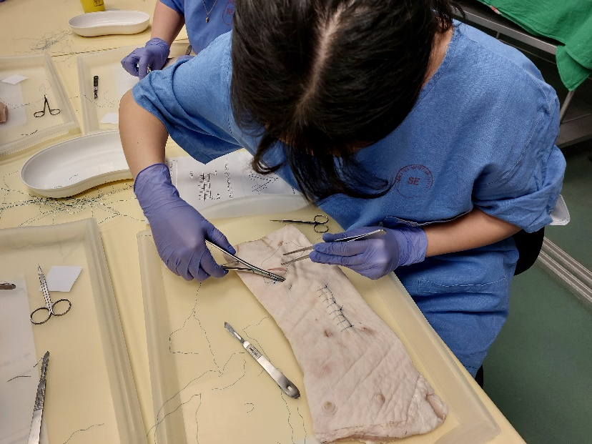

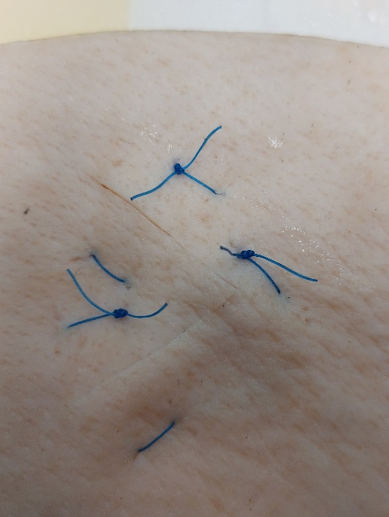
Participants and final results:
SUTURA Competition 2022.03.29
No. | Name |  | Suture point | Time | Time point | Sum | Final grade
1 | SANDERSEN Noomi |  | 17 | 05:42 | 10 | 27 | 5
2 | MOUSAVIZADEH Rose |  | 13 | 06:00 | 9 | 22 | 5
3 | ROSENGREN Malin Soli |  | 15 | 07:41 | 7 | 22 | 5
4 | BAR-YOSEF Shani |  | 16 | 08:39 | 5 | 21 | 5
5 | SUNG Yoonhyo |  | 12 | 08:49 | 4 | 16 | 4
6 | FRANCO Clara Isabelle |  | 7 | 07:10 | 8 | 15 | 4
7 | CHO Minjun |  | 9 | 08:31 | 6 | 15 | 4
8 | SALTE Victoria |  | 14 | 10:46 | 1 | 15 | 4
9 | DOMFROCHT Tal |  | 13 | 10:25 | 2 | 15 | 4
10 | HIMBERG Sebastian |  | 14 | 11:50 | 0 | 14 | 4
11 | MUIS Matilde Osaland |  | 10 | 10:10 | 3 | 13 | 4
12 | MIN Jaewon |  | 13 | 11:20 | 0 | 13 | 4
13 | SCULLY VELEIRO Nataxa Kathleen |  | 10 | 10:52 | 0 | 10 | 4

So, the winners are:
1. SANDERSEN Noomi
2. MOUSAVIZADEH Rose and ROSENGREN Malin Soli
3. BAR-YOSEF Shani

For the first four students (marked with yellow in the table) we offered an excellent (5) mark as the final mark for the Surgical Techniques subject. Placed from 5t^{h} to 10th received good (4) mark, they should later declare the acceptance of this offer. Thanks for the participation of students, the creative work of the staff - Daniella Fehér, Györgyi Szabó, Domokos Csukás, Ramin Talebian - the assistant’s and the teacher assistants’ help.
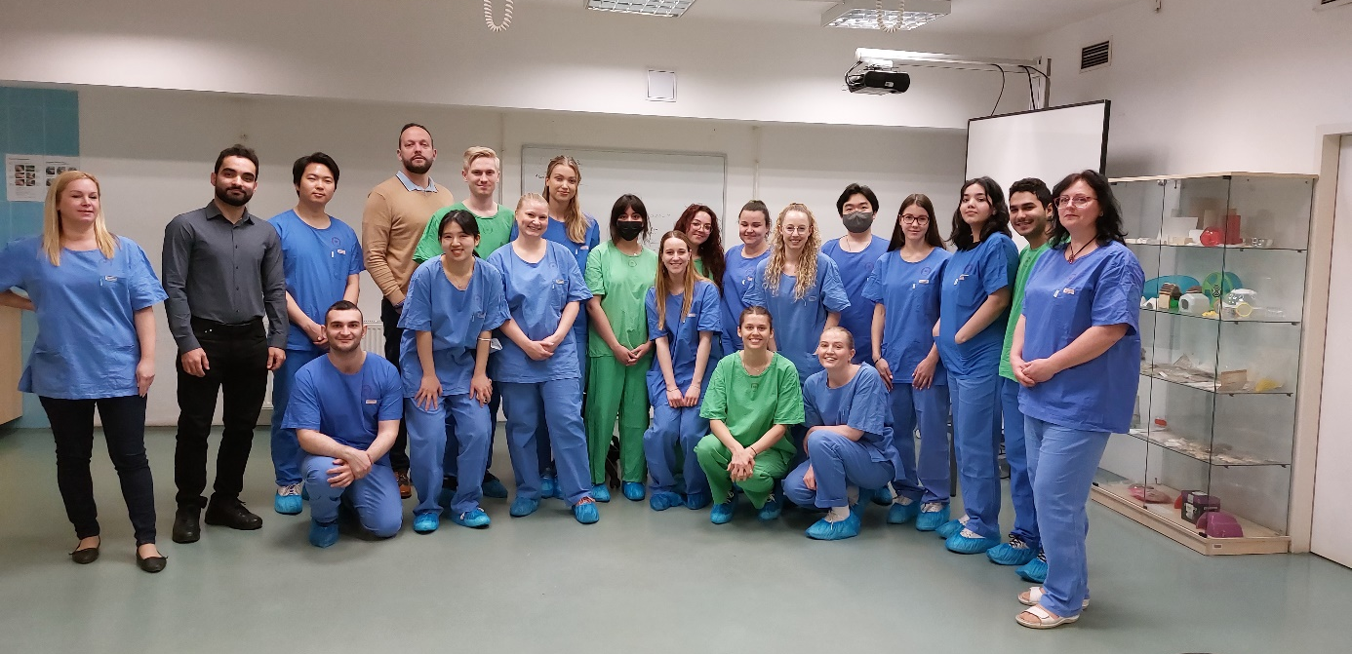

Budapest, 29 March 2022
Dr. Györgyi Szabó and Ramin Talebian

