LAPAROSCOPIC COMPETITION
2nd Semester of 2021/2022 Academic Year
In the 2nd Semester of the 2021/2022 Academic Year, Laparoscopic competition for the fifth time was held on 26 April, 2022 in the 3rd Seminar room (gathering at OL), NET. One person was selected from each group of 3rd-year medical students, who presented the best skill during the 5th and 6th practices. 18 students took part in the first round; then 9 students were allowed to participate in the second round of the competition.
TASK 1- PEG transfer
Using two 5 mm grasping forceps, they needed to pick up each peg with the left instrument, passing it to the right instrument in the middle of the board, then placing it on the pegboard to the right. Once all six pegs had been transferred, the process was repeated but using the right instrument to pass to the left. If a peg was dropped it could not be touched further and penalty was 5 sec.

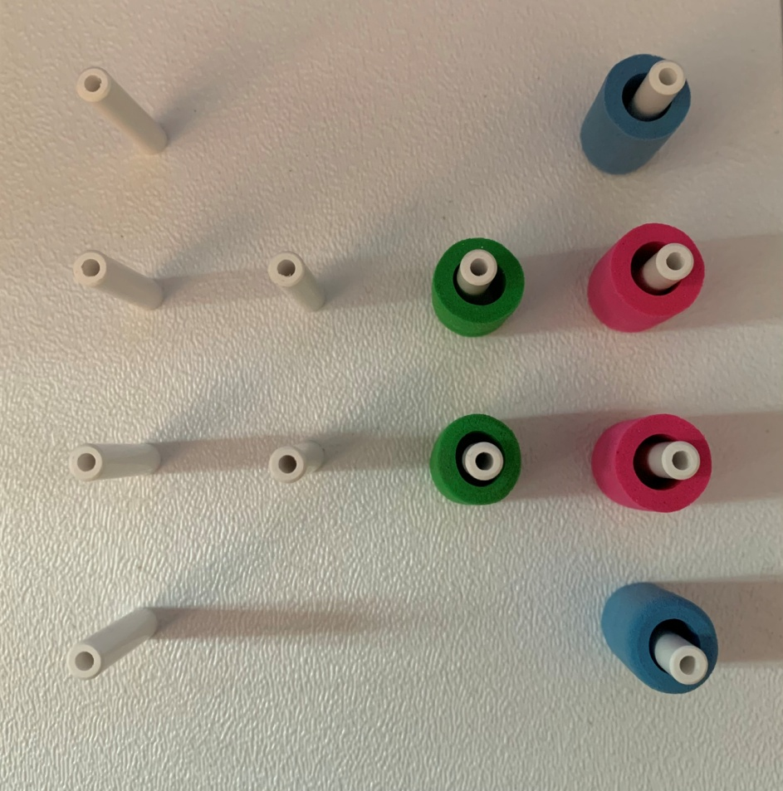

Task 2
Using two 5 mm grasping forceps, they needed to string each pieces of the drinking stick on the thread. The penalty was 5 sec for every missed pieces from the thread.

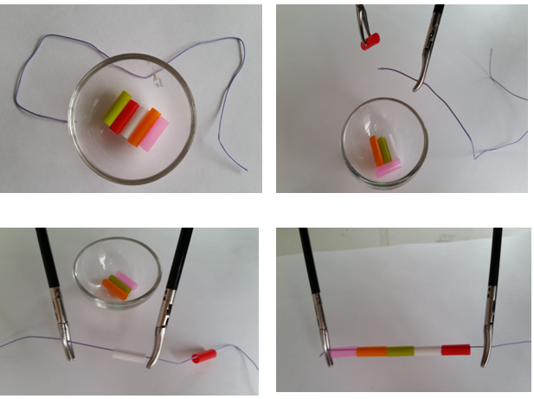

For the first four students (marked with blue in the table) we offered an excellent (5) mark as the final mark for the Surgical Techniques subject. Placed from 5t^{h} to 10th received Grade 4 (with green in the table). All other participants are exempt from the laparoscopic (pelvitrainer) exam station.
FINAL RESULT
CHO Minseok
LEE Chae Yeon
ESCHER Vibeke Helene
KIM Youngjee
PARK Hannah S J
EBRAHIMI Alireza
JUNG Sungin
SOMMER Maria Rahel
OKAMOTO Ryota

Budapest, 26 April 2022
Dr. Daniella Feher and Dr Ramin Talebian

