**EVIDENCE SYNTHESIS TO SUPPORT COVERAGE DECISIONS OF MEDICAL TECHNOLOGIES**

**Hallgatói visszajelzés és akcióterv**

1. **Átalános információk**

**A tanfolyam ideje:** 2023. január 9-12

**Formátum:** személye (streaming: EOK Beznák Aladár terem)

**Kurzus nyelve:** angol

1. **Hallgató visszajelzések az ETEK saját kérdőíve alapján**

• Az összes kitöltő száma: 15

• Az ábrákon az elemszám látható

**1. Összefoglaló értékelés a tanfolyamról**

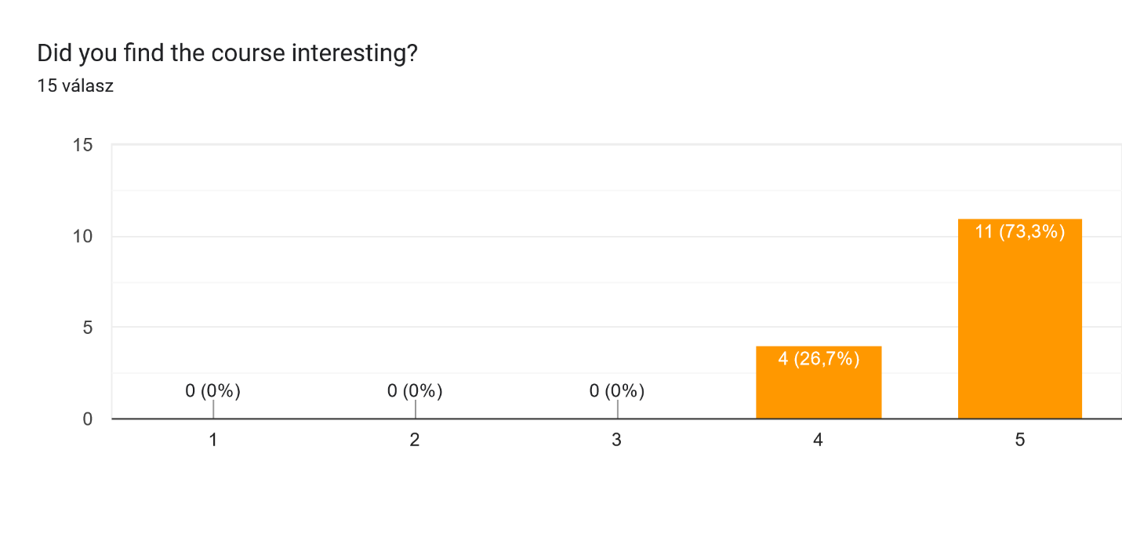

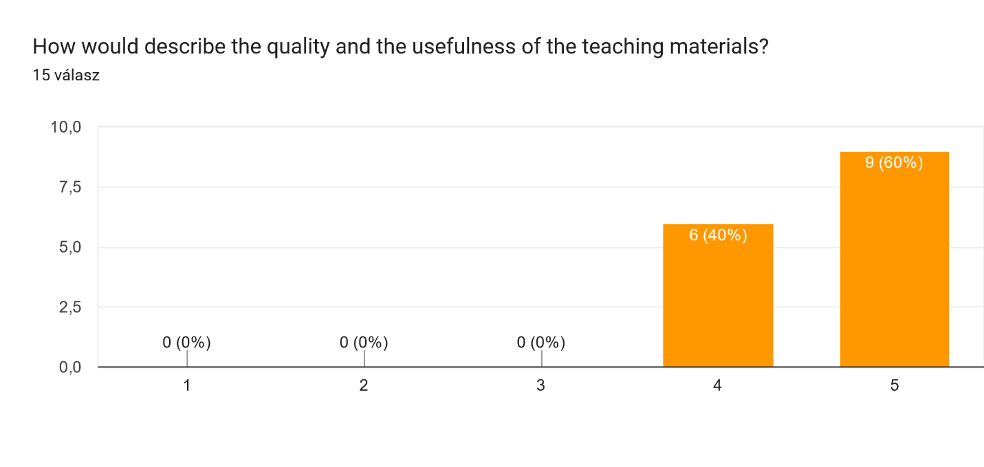

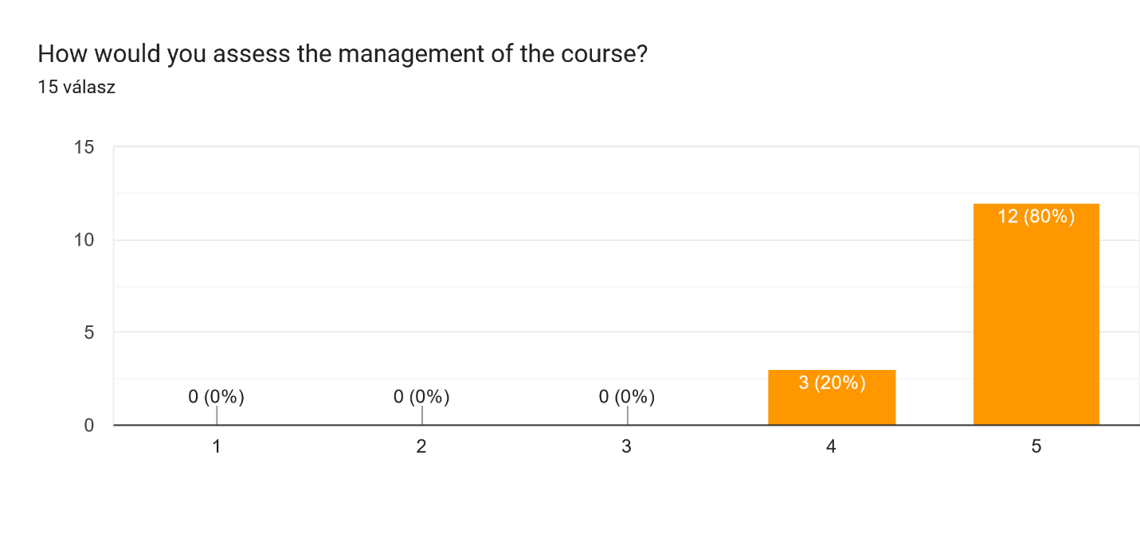

Do you have any additional advice or suggestion to improve the quality of the course? 11 válasz

Nagyon remek volt, sok felmerülő kérdés a kérdés elmondása nélkül is megválaszolásra került! Az egyetemen több statisztikai alapkurzus is van Phd hallgatók számára, a kurzusok összehangolása esetleg segítene azoknak, akik tényeleg 0-ról indulnak. (ha ez lehetséges).

A "kézi" számolások alapját jó volt látni a végén, de pár percben hasznos lehetne az elején. (vagy akár a tárgy elkezdését megelőzően egy amolyan "prerequisite" fileban, ha jól láttam ez lényegében készen is van)

Köszönjük!

slides containing a detailed description of the interpretation of network meta-analysis results would help practice and provide a good reference point for analyzing the results of network meta-analyses during later work as well

Maybe use a program that is available for IOS and WIndows wil make the course easier for some students, explain a bit more some medical details and how they are related, since some of the students are not doctors, it makes more difficult to interpret results and extract information because we do not have a lot of background

i would recommend to have more exercise, more calculation, and a more detailed method part (why we do each steps) - probably one more day would be needed for this

Probably we could have changed our research area for the exam

The course was definitely useful, and will help me to read more critically such meta-analytic papers. It would have been useful if the course material is given in an editable pdf doc, as some times we needed to copy things from it, and also for me it is quite handy when I can make notes on slides rightaway.

It was also useful that we needed to phrase results for the exam, and of course the paper that I have been replicating helped, but it might be also useful in the future if we could practice this during the course/some clues were given. So to see what are the appropriate terms to use when interpreting funnel plot and forest plot, how to interpret "different" or odd cases. Especially at the funnel plot, I felt quite unsure about the proper way of interpretation even though we have practiced it, so I had a sense of understanding.

It was really great that lecturers listened cautiously to our requests and one could really feel that they are aiming for a great course, and it was one. Thanks for everything!

(ps. in this form I would make 2 Qs from this one (copied below): one on the clarity of the aim, and another one on the flow of thinking/logic: To what extent were you able to follow the structure and the logic of the course? (flow of thinking, skills and competences provided))

Dedication of longer time period for the course and the practical part

More credits for this course and add more for the practical metaanalysis and about

**2. A tanfolyam értékelése a személyes körülmények (végzettség, felkészültség, munkakör, stb.) kontextusában**

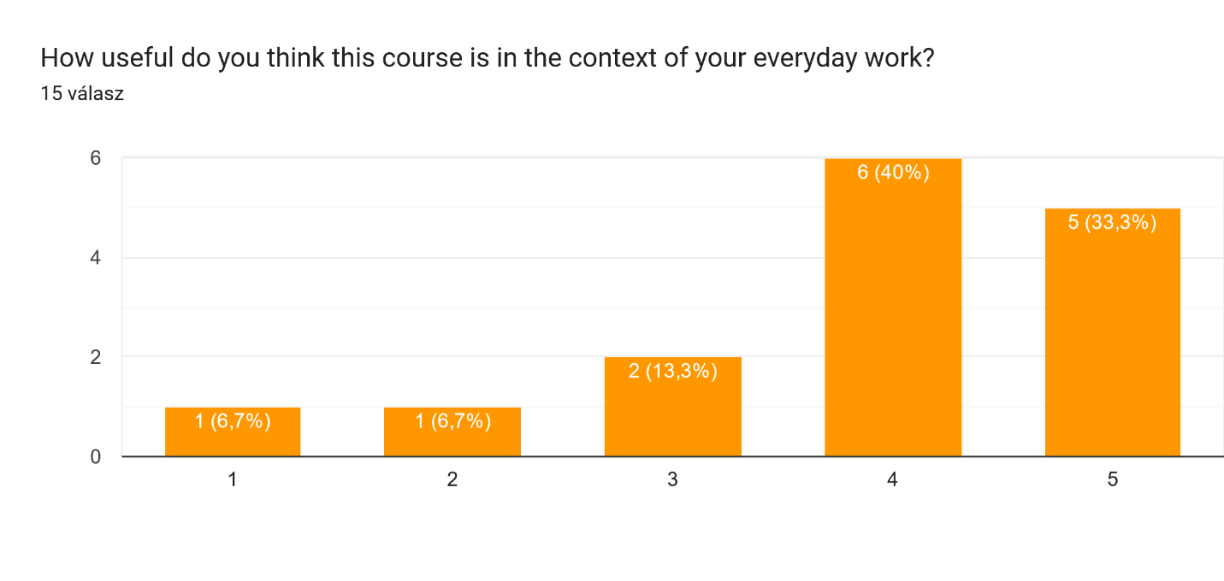

**3. Kiértékelések az egyes előadók által tartott napokra vonatkozóan**

**Zoltán Vokó**

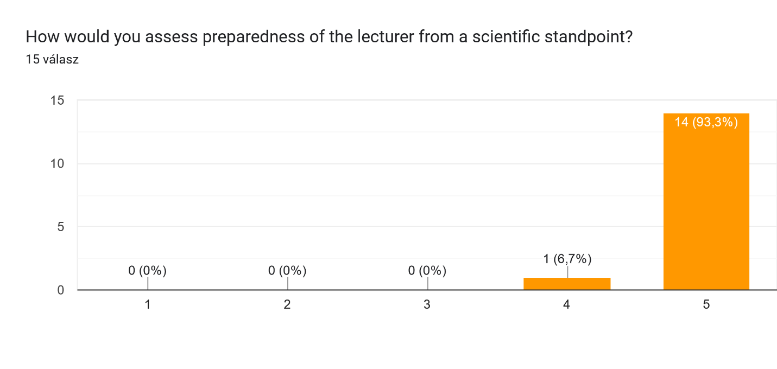

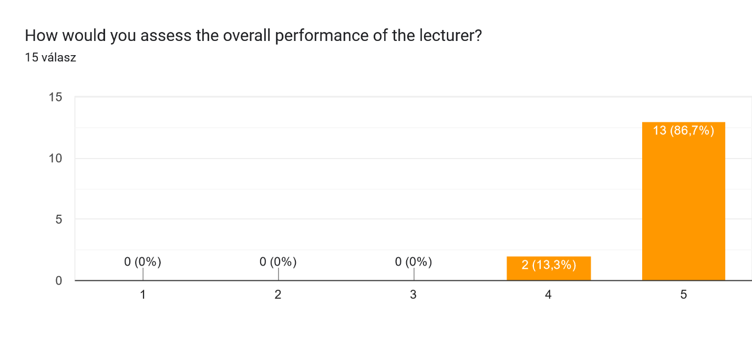Do you have any comments, notes or suggestions for the lecturer? 8 válasz

Maybe more insigths in why this or that result is significative, the relationship between the statistical significance and the actual effects and relationships, so we can interpret better our obtained results

very professional, inspiring

It is very helpful when you perform the mathematical analysis real time on the table (like when explaining the formulas for standard errors etc), be courage to do it

I liked the fact the he used the board for explanation

That was a great courses that I ever had in Semmelweis. Only due to the meeting is every day, so made me cant study well in limited time.

He was kind and great.

**Zsuzsanna Petykó**

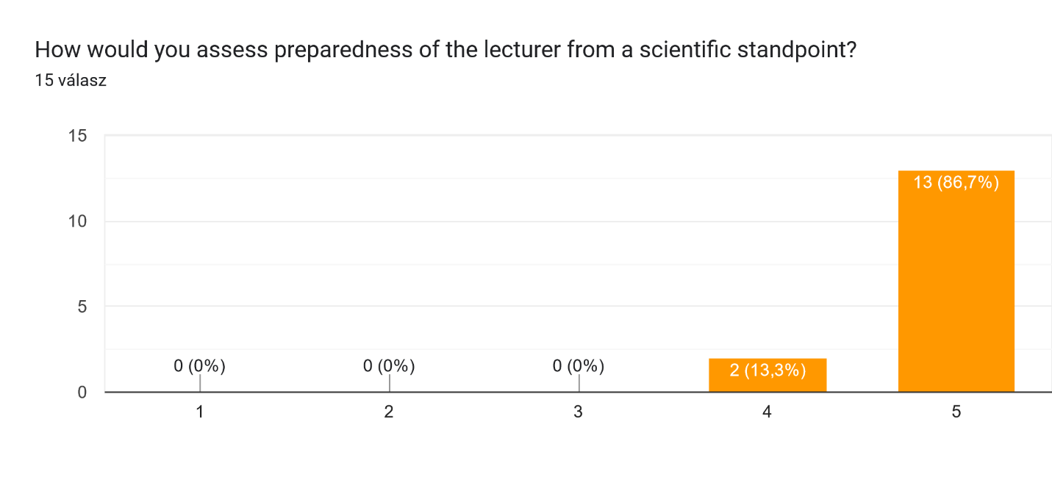

Do you have any comments, notes or suggestions for the lecturer? 5 válasz

I liked the class, I think maybe give more time between each step to make it easy to follow the practical tutorial part of the class of SLRs.

You can be a little bit slower when presenting 'Advanced Search' functions of PubMed 'cause unexperienced participants are also present

Provided clear explanation of the concepts

The lecturer was interesting when explaining the course.

great!

1. **Beavatkozások**

A hallgatói visszajelzések alapján az alkalmazott példák orvosi hátterét jobban meg fogjuk világítani a következő alkalommal.

A kedvező visszajelzés alapján folytatjuk és kiterjesztjük az a gyakorlatot, hogy az alkalmazott számításokat a hallgatókkal együtt a táblán vezetjük le, amellett, hogy a diák is tartalmazzák ezeket.

Készítette:

Dr. Vokó Zoltán

egyetemi tanár, a PhD tanfolyam vezetője

Budapest, 2023. január 31.