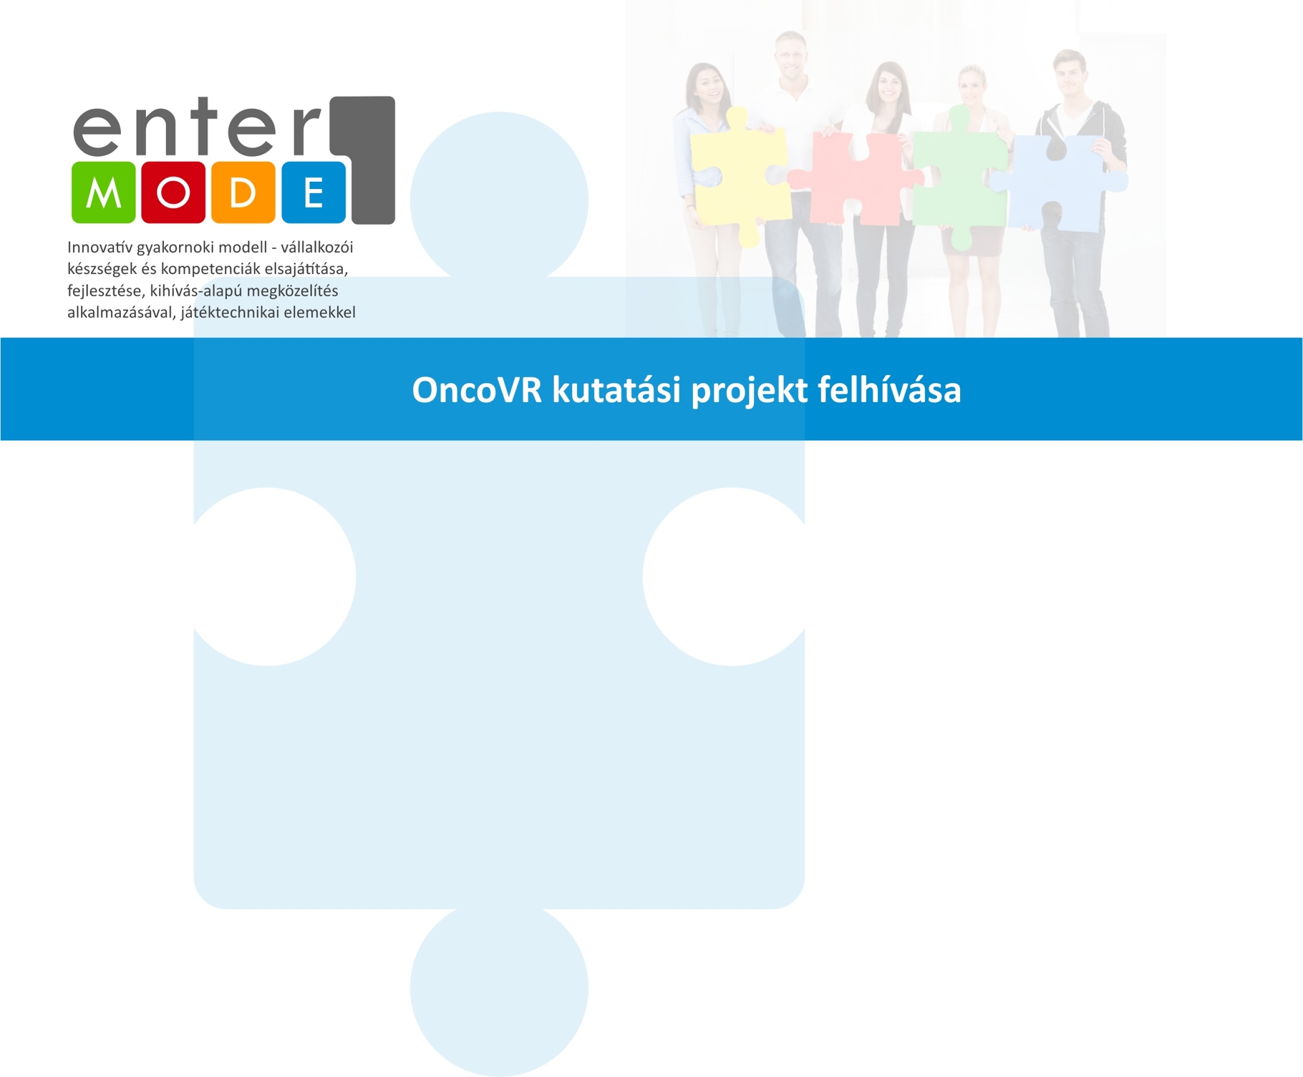

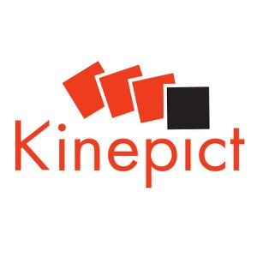
Internship Announcement

Overview of The company
Kinepict Health Ltd. is a Budapest based Hungarian start-up bringing to the market a revolutionary medical imaging technology which benefits both patients and doctors.
Please visit our site to find out more about the company: www.kinepict.com
In medical diagnostics, X-ray imaging is the most common method but it has many side effects. Our team has developed an innovative approach that reduces the current risk and generates much better images. Kinepict’s patented technology, makes angiography safer by reducing contrast medium and X-ray dose and provides extra information to facilitate better diagnosis.
Internship
We are looking for intern students interested in
- radiology to join the work on analyzing x-ray angiography image series
- image processing to join the efforts of developing new medical image analysis and representation tools
- marketing strategy to participate in the development of a post COVID sales and marketing strategy of the Kinepict software product
to join our team.
Requirements
- Fluent English knowledge
- Interest in the life of start-ups
- Willingness to participate in a real innovation-value-creating activity for 3+ months
Contact
If you are interested in the opportunity, please submit your resume to: entermode@emk.sote.hu
Employment type: part-time, flexible working
Job location: Budapest, Júlia str 11. 1026 + home office
Deadline for applications: 5 October 2020
Web: https://kinepict.com/regionselect.xhtml

EnterMode - AIMS & OBJECTIVES
EnterMode aims to stimulate entrepreneurial skills of higher education teaching staff and company staff and develop the entrepreneurial mind-set and related skills of higher education students. Its main objectives are:
- Raising awareness on the importance of internships for higher education students in general and for building entrepreneurial skills
- Developing HEIs–companies partnerships for the promotion of entrepreneurial education of higher education students
- Capacity building of higher education teaching staff and companies’ trainers, to organise entrepreneurial teaching and learning
- Developing entrepreneurial mind-set, skills and competences of higher education students, during their internships
- Developing an integrated model of entrepreneurship skills acquisition that includes different levels of learning, using online serious game
- Building a community of practice that allows for developing common practice and integrating newcomers into existing business communities
- Developing learning analytics to enable the tracking of learning progress and adapt the EnterMode program to personal and organisational needs.

